ASSIGNMENT
HALL TICKET NUMBER | 0425046024
NAME OF THE STUDENT | KOTARETI SREEDEVI
LEARING TRACK | DATA ANALYTICS WITH TABLEAU

Sheet – 01 – Area Chart
1. From the Data pane, drag Order Date to the Columns Shelf.
2. Right-click YEAR (Order Date) on the Columns shelf.
3. Select Month
. 4. Drag Quantity to the Rows Shelf.
5. Drag Ship Mode to Color on the Marks card
. 6. On the Marks card, open the drop-down menu.
7. Select Area as the chart type.

OUTPUT :
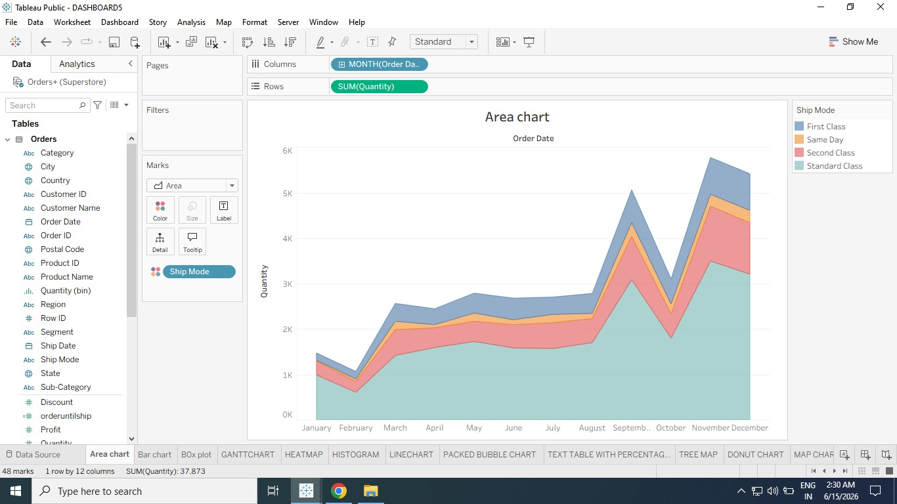

Sheet – 02 – Bar Chart
- Drag Sales to the Rows Shelf.
- Tableau automatically aggregates Sales as SUM(Sales). •
- Since Order Date is used, Tableau first shows a Line Chart representing yearly sales trends.
- On the Marks Card, click the drop-down menu.
- Select Bar. Add Ship Mode Colors
- Drag Ship Mode to Color on the Marks card. Add Region Comparison
- Drag Region to the Rows Shelf (left of Sales). Filter Only West Region
- Drag Region again to the Filters Shelf.
- In Filter dialog box: Uncheck Central Uncheck East Uncheck South Keep only West

OUTPUT:

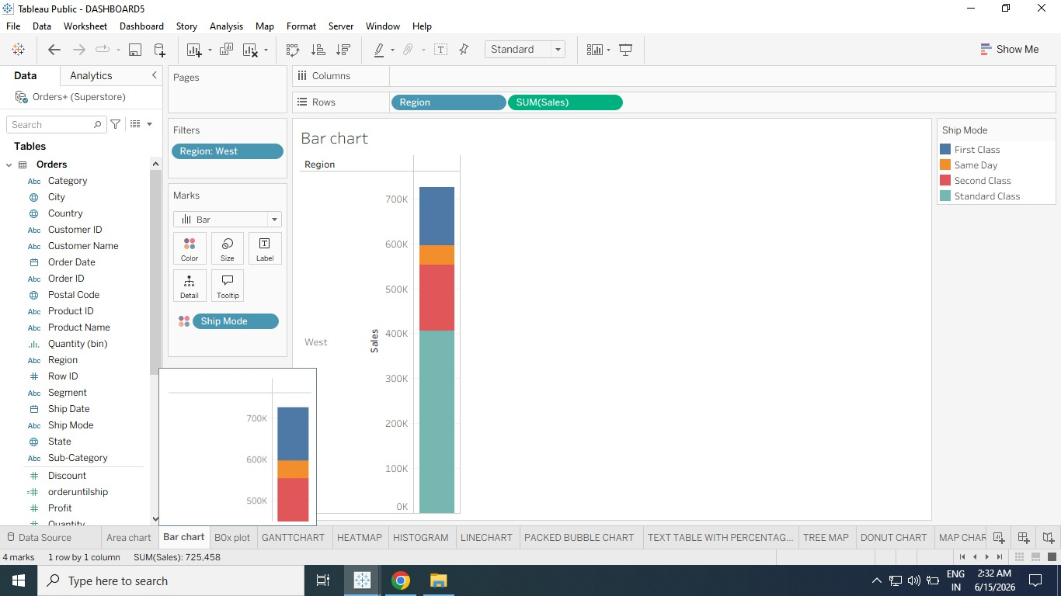

Sheet – 03 - Box Plot
1. Drag Segment → Columns Shelf.
2. Drag Discount → Rows Shelf. Change Aggregation to Average
3. Click Discount on Rows Shelf.
4. Hover over Measure (Sum).
5. Change aggregation to Average. Add Region Dimension
6. Drag Region → Columns Shelf.
7. Drop it to the right of Segment. Convert to Box Plot
8. Click Show Me in toolbar.
9. Select Box-and-Whisker Plot. Correct Region Placement
10. Drag Region from Marks card back to Columns Shelf, right of Segment. Disaggregate Data
11. Go to Analysis Menu.
12. Uncheck Aggregate Measures. Swap Axes (Horizontal View) 13. Click Swap Rows and Columns button.
OUTPUT:
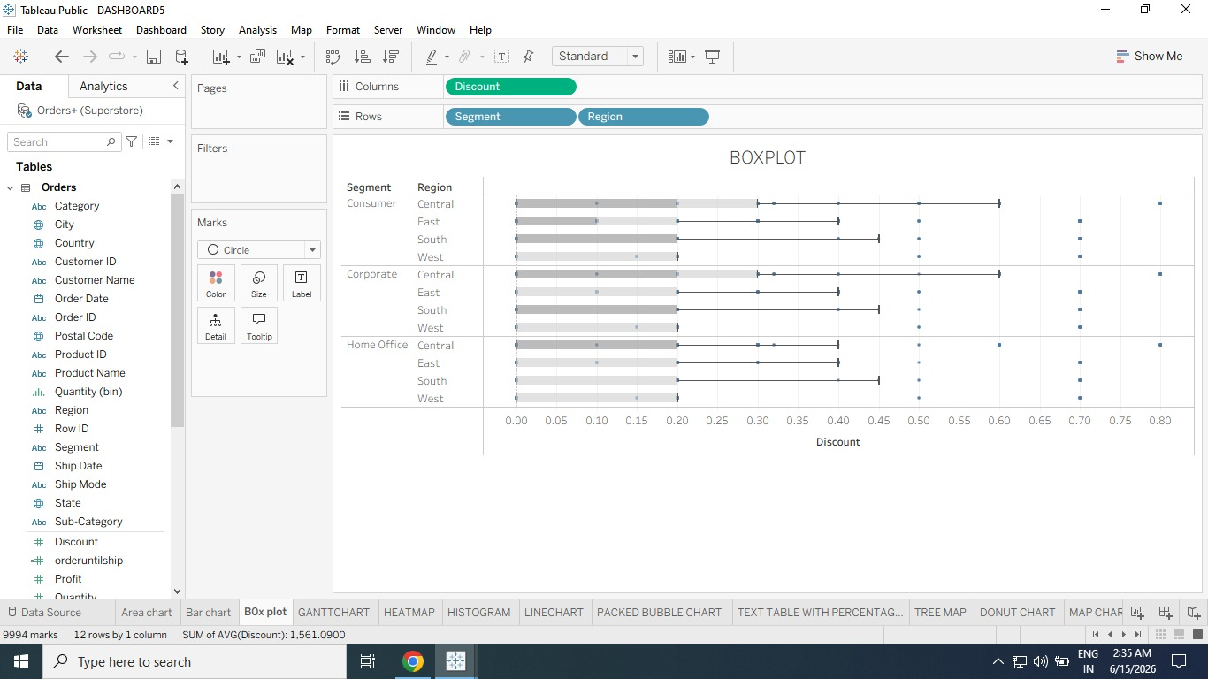

Sheet – 04 - Gantt Chart Step
1: Add Order Date to Columns
1. Drag Order Date from Dimensions.
2. Drop it on the Columns Shelf.
3. Tableau automatically shows YEAR(Order Date)
Step 2:
Change Year to Week Number
1. Click drop-down arrow on YEAR(Order Date) in Columns shelf.
2. Select:
More Week Number Now columns display weekly timeline.
Step 3: Add Rows Dimensions
1. Drag Sub-Category to Rows Shelf.
2. Drag Ship Mode to Rows Shelf and place it right side of Sub-Category.
Now rows show:
Furniture First Class / Standard Class etc. Office Supplies etc.
Step 4:
Change Marks Type to Gantt Bar
1. In Marks card click dropdown.
2. Select Gantt Bar Now bars appear across timeline.
Step 5:
Create Calculated Field We need shipping delay days.
1. Click Analysis Create Calculated Field
2. Name: OrderUntilShip
3. Formula: DATEDIFF('day',Order Date,Ship Date)
4. Click OK Step
6: Add Delay to Size
- Drag OrderUntilShip to Size on Marks card. Bars become longer based on shipping days.
- Step 7:
- Change SUM to AVG
- 1. Right-click SUM(OrderUntilShip) on Marks card.
- 2. Select: Measure Average Now average shipping delay is shown.
- Step 8:
- Add Color by Ship Mode
- 1. Drag Ship Mode to Color in Marks card. Now each ship mode gets different color.
OUTPUT:
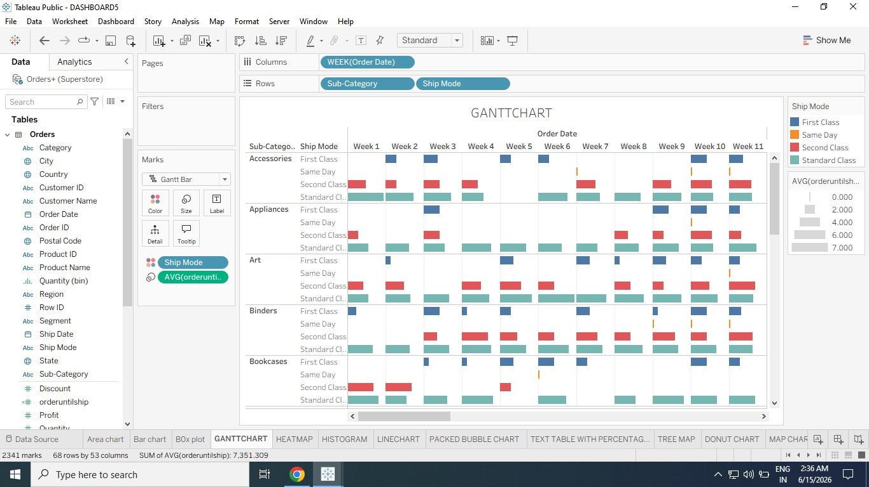

Sheet – 05 - Heat Map Step
1: Add Segment to Columns
1. Drag Segment from Dimensions.
2. Drop it on Columns Shelf. You will see: Consumer Corporate • Home Office
Step 2:
Add Region and Sub-Category to Rows
1. Drag Region to Rows Shelf
2. Drag Sub-Category to Rows shelf and place it to the right of Region. Now hierarchy becomes: Central Chairs, Tables, Phones etc. East South West
Step 3:
Add Profit to Color
1. Drag Profit measure.
2. Drop it on Color in Marks card.
Step 4:
Add Borders to Cells
1. Click Color on Marks card.
2. Under Border, choose Medium Gray This makes each box clearer.
Step 5:
Change Color Palette
1. On Profit color legend click dropdown arrow.
2. Select Edit Colors In dialog box: Palette = Red-Black Diverging Check Use Full Color Range Click Apply Click OK Now: Profit = Black / Dark Loss = Red
Step 6:
Add Sales to Size
1. Drag Sales measure.
2. Drop it on Size in Marks card. Now box size represents Sales amount.
Large box = High Sales • Small box = Low
7: Increase Box Size
1. Click Size on Marks card.
2. Move slider to right until boxes fit properly
output:
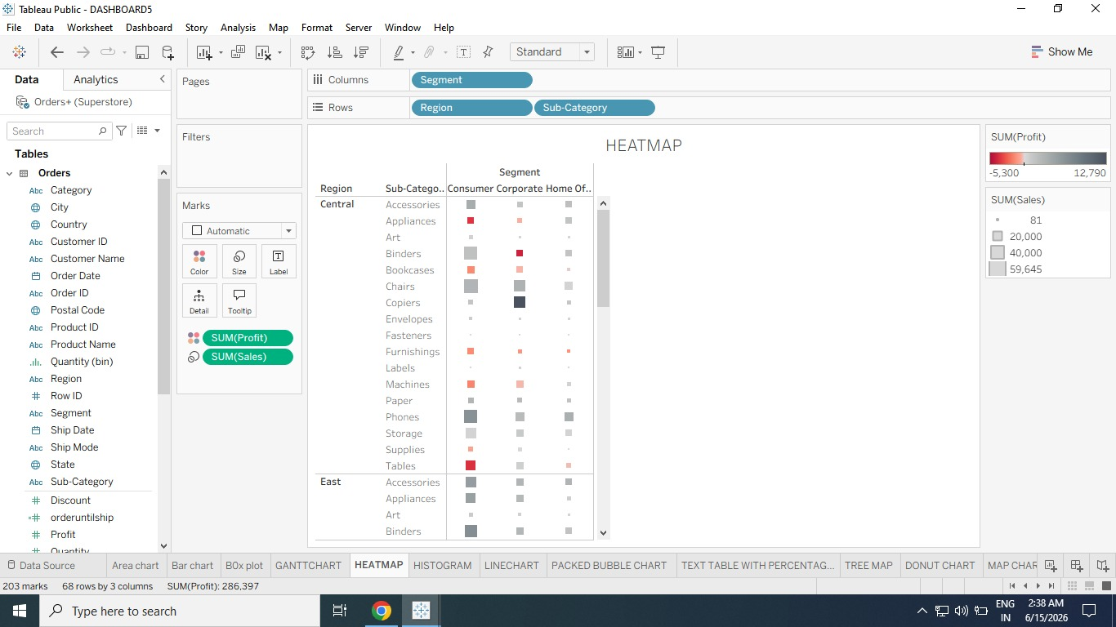
Sheet – 06 - Histogram:
Step 1:
Drag Quantity to Columns
1. From Measures, drag Quantity
2. Drop it on Columns Shelf Step
2: Create Histogram Using Show Me
1. Click Show Me (top right corner)
2. Select Histogram Tableau Automaticall
Does: Creates Quantity (bin) on Columns Moves Quantity to Rows
Changes aggregation to CNT(Quantity)
Step 3: Understand Histogram
X-Axis:
Quantity Bins Y-Axis:
Count of Orders
Example:
Around 4800 orders had quantity = 2
Around 2400 orders had quantity = 4
Step 4:
Add Segment to Color
1. Drag Segment from Dimensions
2. Drop it on Color in Marks card
Now bars become stacked by:
Consumer
Corporate
Home Office
Step 5:
Copy Count to Label
1. Hold Ctrl
2. Drag CNT(Quantity) from Rows shelf to Label on Marks card (Using Ctrl copies field.)
Step 6:
Convert Labels to Percent of Total
- Right-click CNT(Quantity) on Marks card
- Select:
Quick Table Calculation → Percent of Total
Now labels show percentages
Output:

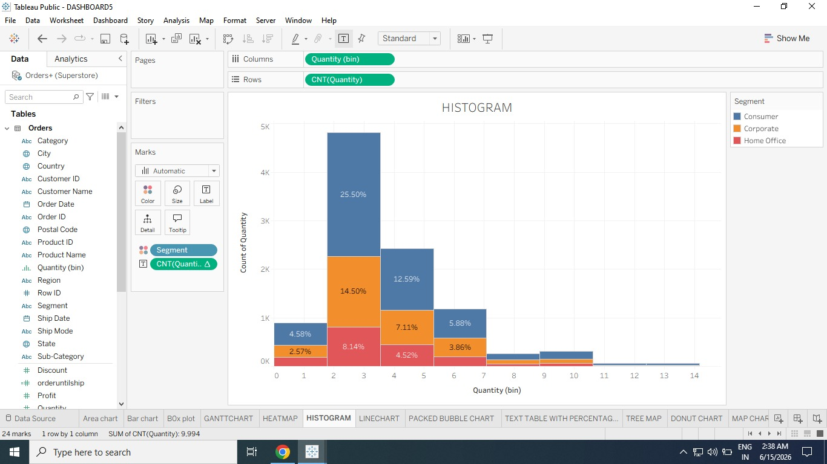

Sheet – 07 - Line Chart:
Step 1:
Add Ship Date to Columns
1. Drag Ship Date from Dimensions.
2. Drop it on Columns Shelf.
Tableau shows: YEAR(Ship Date)
Step 2:
Add Sales to Rows
1. Drag Sales measure.
2. Drop it on Rows Shelf Tableau creates a line chart.
Step 3:
Add Profit to Rows
1. Drag Profit measure.
2. Drop it on Rows shelf, right side of Sales
Now Tableau creates two separate axes:
Sales Axis Profit Axis
Step 4:
Blend the Axes
1. Drag SUM(Profit) from Rows shelf.
2. Drop it directly on the Sales Axis.
(You will see two pale green lines.)
Release mouse.
Now Sales and Profit share same axis.
Step 5:
Change Year to Month
1. Click dropdown on YEAR(Ship Date) in Columns shelf.
2. Select: Month (from lower continuous section)
Now chart becomes monthly trend line across years.
Step 6:
Observe Trend You may notice:
✅ Higher values near year-end
✅ Repeating yearly spikes
✅ Seasonal business growth This is called Seasonality.
Step 7:
Add Forecast
1. Click Analytics Pane
2. Drag Forecast
3. Drop into chart area
Tableau automatically predicts future trend.

Output:
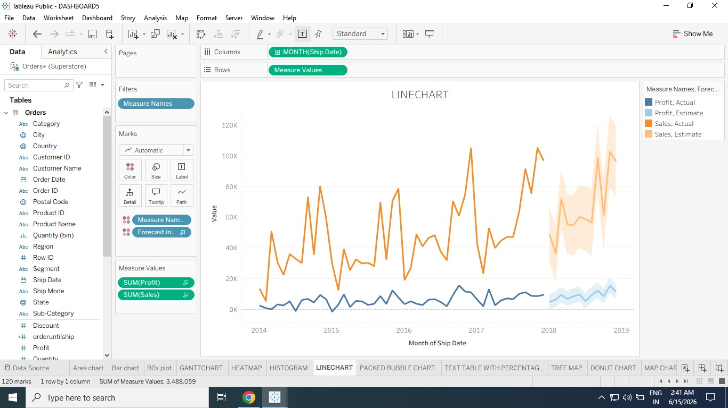

Sheet – 08 - Packed Bubble Chart
Step 1:
Add Category to Columns
1. Drag Category from Dimensions
2. Drop it on Columns Shelf You will see:
Furniture
Office Supplies
Technology
Step 2:
Add Sales to Rows
1. Drag Sales measure
2. Drop it on Rows Shelf Tableau creates a Bar Chart by default.
Step 3:
Change to Packed Bubbles
1. Click Show Me (top right)
2. Select Packed Bubbles Now
Tableau creates bubbles for:
Furniture
Office Supplies
Technology Bubble size = Sales
Step 4:
Add Region to Detail
1. Drag Region
2. Drop it on Detail in Marks card
Now each Category splits into:
East
West
Central
South
More bubbles appear.
Step 5:
Add Profit to Color
1. Drag Profit
2. Drop it on Color Now bubble
color represents Profit.
Example:
Dark Blue = High Profit
Light Blue = Lower Profit
Orange/Red (if palette changed) = Loss
Step 6:
Add Region to Label
1. Drag Region
Now each bubble displays region name
Output: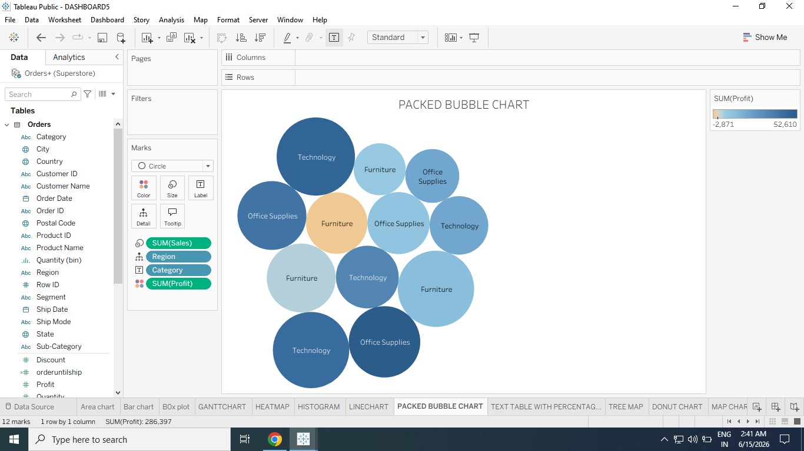

Sheet – 09 - Pie Chart Step
1: Add Profit to Columns
1. Drag Profit measure
2. Drop it on Columns Shelf
Step 2:
Add Category to Rows
1. Drag Category dimension
2. Drop it on Rows Shelf
Tableau creates a Bar Chart by default.
Step 3:
Change to Pie Chart
1. Click Show Me (top-right)
2. Select Pie Chart What Tableau Automatically Does After selecting
Pie Chart
: ✅ Mark Type changes to Pie
✅ SUM(Profit) moves to:
Angle
Size
✅ Category moves to:
Color
Step 4:
Increase Pie Chart Size Option 1
1. Click Fit menu (toolbar)
2. Select Entire View Option 2:
1. Click Size on Marks card
2. Move slider right Now pie chart becomes larger.
Step 5:
Add Labels
1. Drag Category
- Drop it on Label in Marks card
- Now chart displays:
- Furniture
Office Supplies
Output:

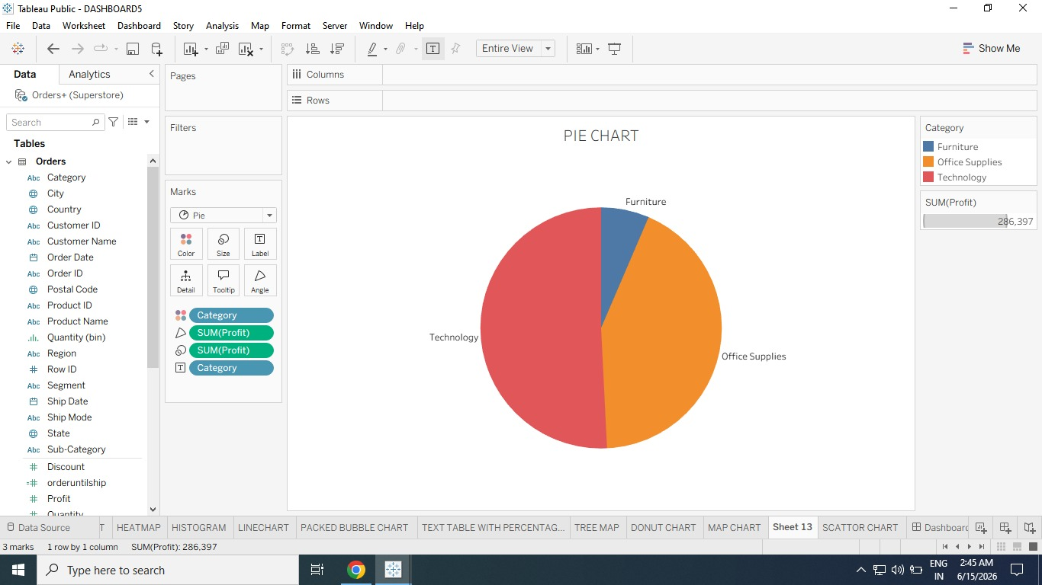

Sheet – 10 - Scatter Plot:
Step 1:
Add Sales to Columns
1. Drag Sales measure
2. Drop it on Columns Shelf Tableau creates horizontal axis.
Step 2:
Add Profit to Rows
1. Drag Profit measure
2. Drop it on Rows Shelf Tableau creates vertical axis
Now you get one mark scatter plot.
Step 3:
Add Category to Color
1. Drag Category dimension
2. Drop it on Color in Marks card
Now marks split into:
Furniture
Office Supplies
Technology
Each category gets different color.
Step 4:
Add Region to Detail
1. Drag Region
2. Drop it on Detail in Marks card
Now more marks appear
. Because each Category is divided by:
Central
East
South
West
Total marks = Category × Region
Step 5:
Add Trend Lines
1. Click Analytics Pane
2. Drag Trend Line
3. Drop it on chart
Select:
Linear

Output:
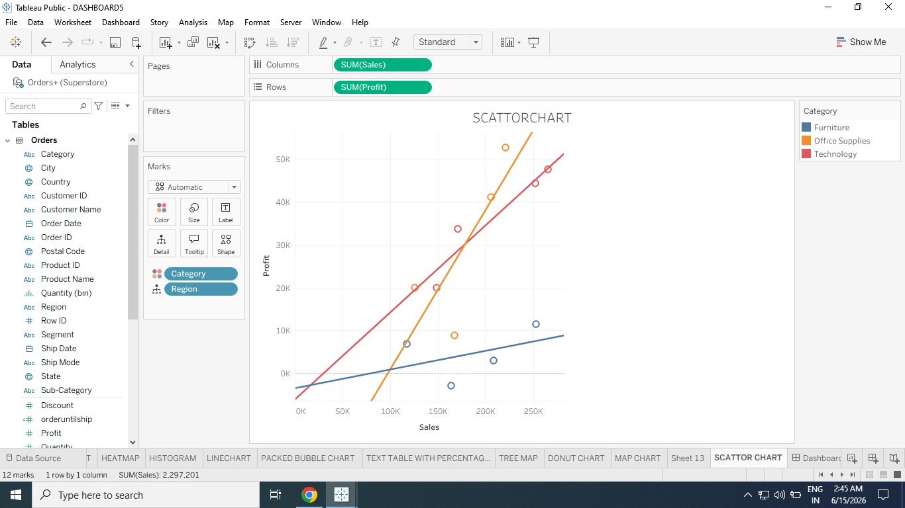

Sheet - 11 Text Table with Percentages
Step 1:
Add Order Date to Columns
1. Drag Order Date dimension
2. Drop it on Columns Shelf Tableau displays: YEAR(Order Date)
Step 2:
Add Sub-Category to Rows
1. Drag Sub-Category
2. Drop it on Rows Shelf Now a table structure is created.
Rows = Sub-Categories Columns = Years
Step 3:
Add Sales to Text
1. Drag Sales
2. Drop it on Text in Marks card Now each cell shows:
SUM(Sales) for each year and sub-category.
Step 4:
Add Region to Rows
1. Drag Region
2. Drop it to the left side of Sub-Category in Rows shelf Now rows become:
Central → Chairs
Central → Phones
East → Chairs
East → Phones etc.
Step 5:
Convert Sales to Percentages
1. Right-click SUM(Sales) on Marks card
2. Select:
Add Table Calculation
Step 6:
Configure Table Calculation In Dialog Box:
Calculation Type:
Percent of Total Compute Using:
Pane (Down)
Then click OK

Output:
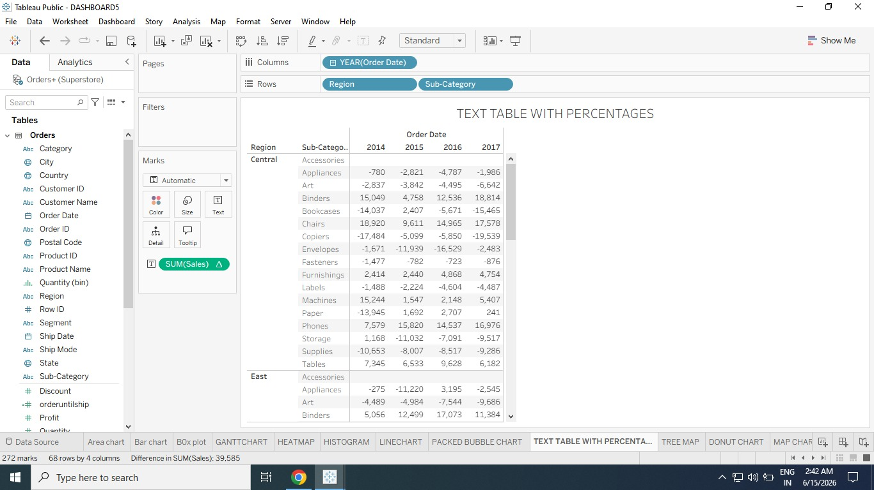

Sheet - 12 Tree map Step
1: Add Sub-Category to Columns
1. Drag Sub-Category dimension
2. Drop it on Columns Shelf
You will see category names on horizontal axis.
Step 2:
Add Sales to Rows
1. Drag Sales measure
2. Drop it on Rows Shelf
Tableau creates a Bar Chart by default.
Step 3:
Change to Treemap
1. Click Show Me (top-right)
2. Select Treemap
Now Tableau creates rectangles for each Sub-Category.
Default Treemap Meaning
Feature Represents
Rectangle Size
Sales Rectangle Color Sales
Example:
Large Dark Box = High Sales
Small Light Box = Low Sales
Step 4:
Add Ship Mode to Color
1. Drag Ship Mode
2. Drop it on Color in Marks card
Now rectangles are colored by:
First Class
Second Class
Standard Class
Same Day
Sales still controls size.
Step 5:
Alternative View (Profit Color)
If you want profit analysis:
1. Click Undo to remove Ship Mode
2. Drag Profit
3. Drop it on Color Now:
Size = Sales
Color = Profit

Output:
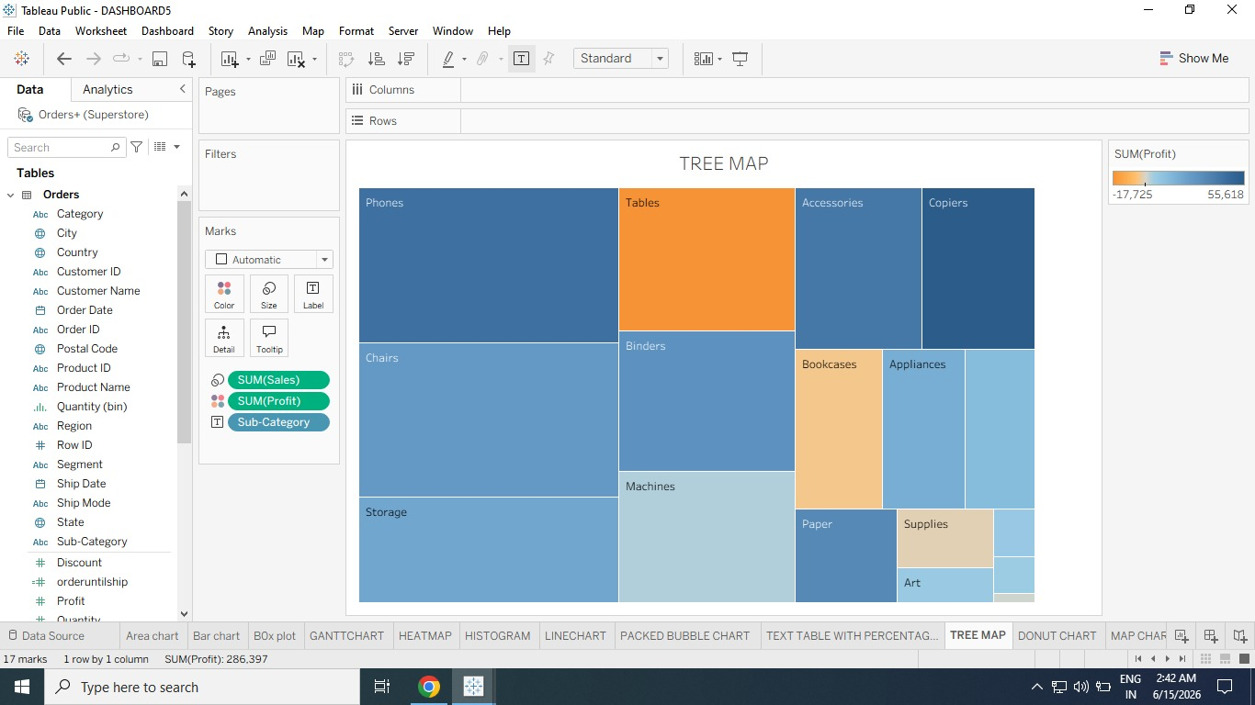

Sheet – 13 - Donut Chart
Step 1:
Create a Calculated Field
1. Go to the Analysis menu.
2. Select Create Calculated Field.
3. Name the field as Zero.
4. In the formula area,
type: 0 5. Click OK. Step
2: Drag Zero to Rows
- From the Measures section,
- drag Zero to the Rows shelf
Step 3:
Convert into Pie Chart
1. In the Marks card, click Automatic.
2. Select Pie.
3. From the toolbar, choose Fit Entire View.
Step 4:
Increase Pie Size
1. In the Marks card, click Size.
2. Increase the size slider.
This creates a larger pie chart.
Step 5:
Create Second Pie for Donut Hole
1. Again drag Zero from Measures to the Rows shelf.
2. Place it on the right side of the first SUM(Zero)
Now two pie charts appear
Step 6:
Create Dual Axis
1. Right-click on the second SUM(Zero) in Rows.
2. Select Dual Axis. Now both pie charts overlap.
Step 7:
Create the Inner Circle
1. In the Marks card, click the second SUM(Zero).
2. Click Size and reduce the size slightly.
3. Click Color.
4. Select White color.
This creates the donut hole effect.
Step 8:
Add Region Colors
1. Click the first SUM(Zero) Marks card.
2. Drag Region to Color.
Now each region gets different colors.
Step 9:
Add Labels
1. Drag Region to Label on the Marks card.
2. Drag Sales to Label.
3. Drag Sales to Angle
The pie slices now display sales values and adjust according to sales.
Step 10:
Add Total Sales in Center
1. Click the second SUM(Zero) Marks card.
2. Drag Sales to Label.
3. Click Label Text.
4. Click the three dots (...) beside text editing.
Type:
Total Sales
- Click OK.
Now the center of the donut chart displays Total Sales.
Output:
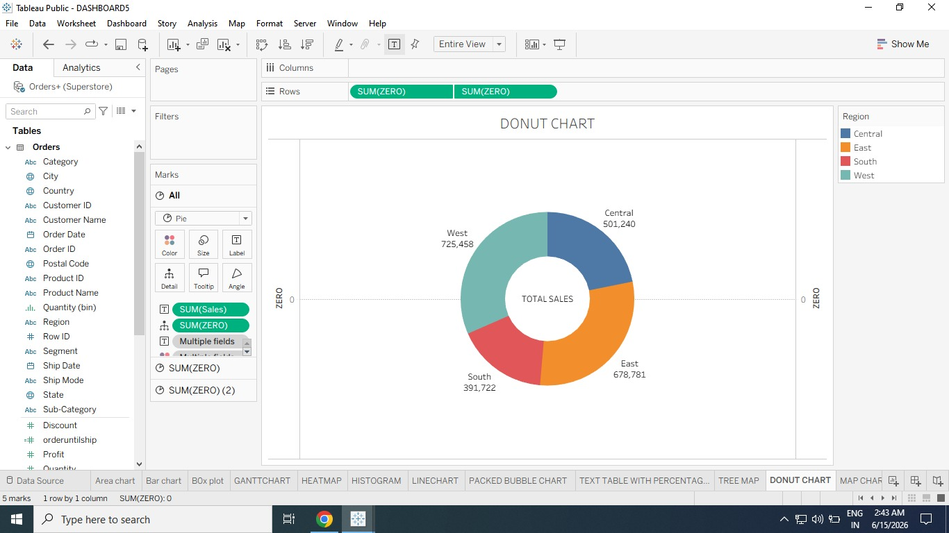

Sheet – 14 - Map Chart
Step 1:
Create a Basic Map
1. From the Data Pane, drag State to the workspace.
2. Tableau automatically generates a map using Latitude and Longitude
Step 2:
Add Sales Information
1. Drag Sales from Measures to Color in the Marks card.
2. The map now displays sales values with different colors.
Step 3:
Change Map Type
1. In the Marks card, click Automatic.
2. Select Map or Filled Map.
3. Map Shows circles on locations.
4. Filled Map Fills states with colors.
Step 4:
Adjust Colors
1. Click Color on the Marks card.
2. Select Edit Colors.
3. Choose a color palette (Purple).
4. Click OK. Step
5: Add Labels
1. Drag State to Label.
2. Drag Sales to Label.
Now each state shows its sales value.
Step 6:
Add Region Filter
1. Drag Region to the Filters shelf.
2. Select All regions.
3. Click OK.
This allows regional analysis on the map.
Step 7:
Add Profit Details
- Drag Profit to Tooltip.
Hover over any state to view Sales and Profit details.
Step 8:
Format the Map
1. Go to Map Map Layers.
2. Adjust:

Output:
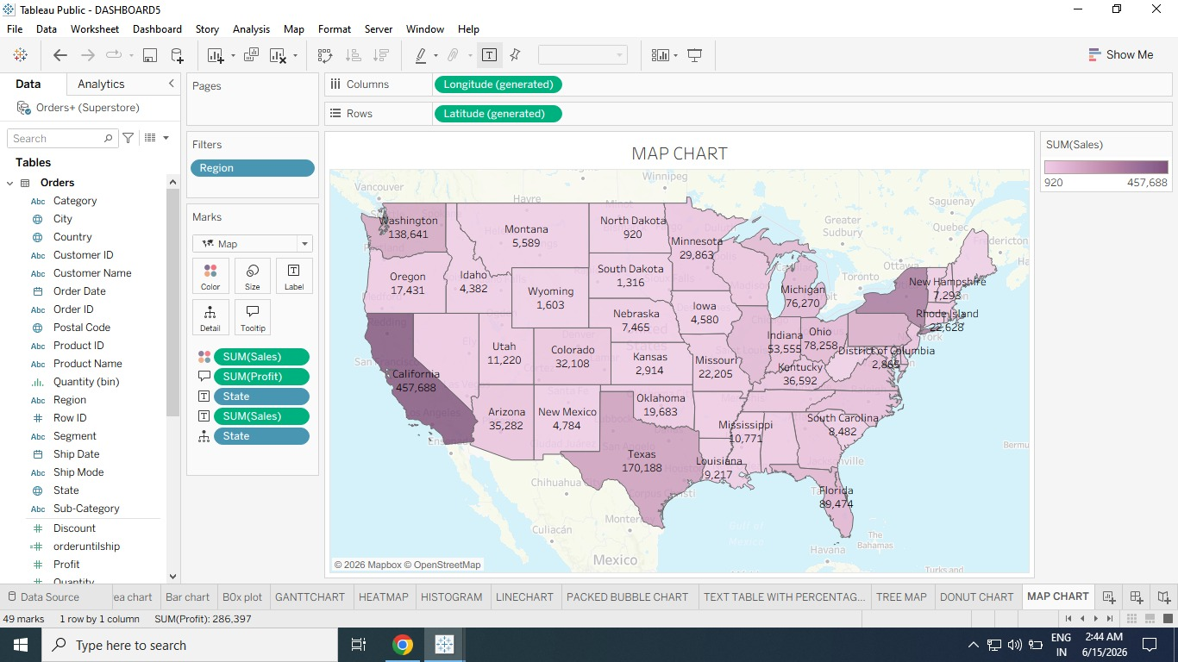

DASHBOARDS:1
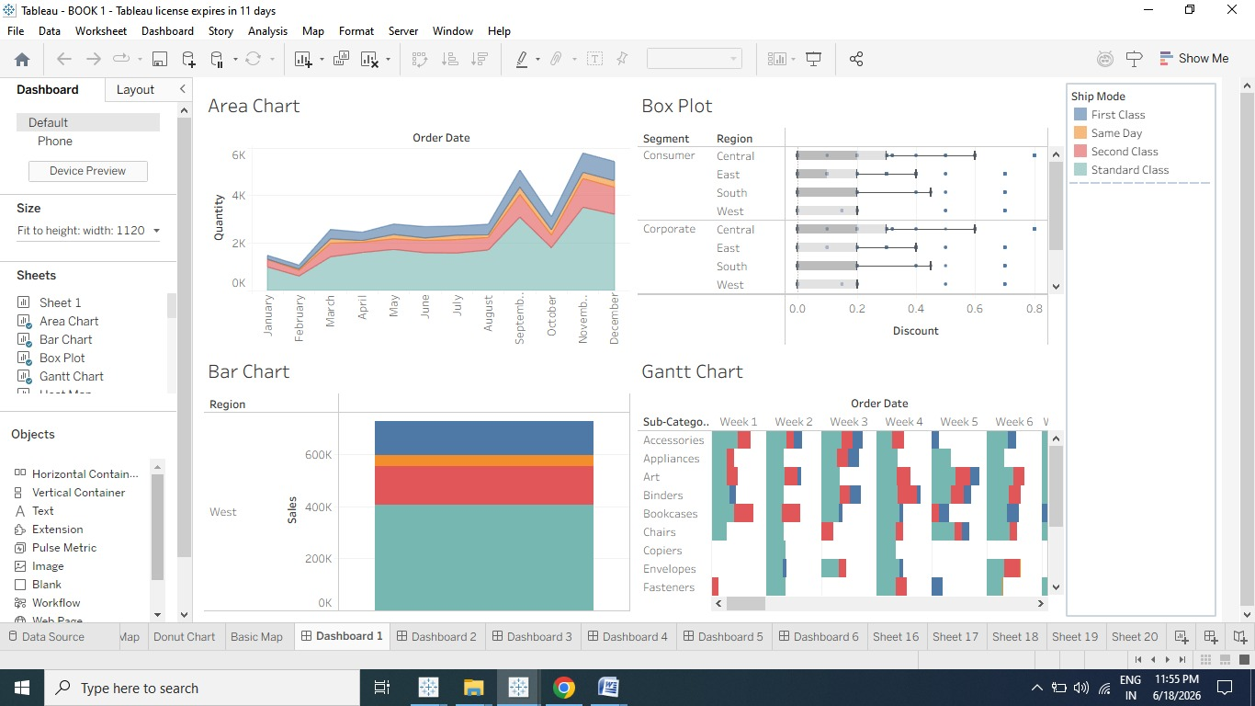
DASHBOARDS:2
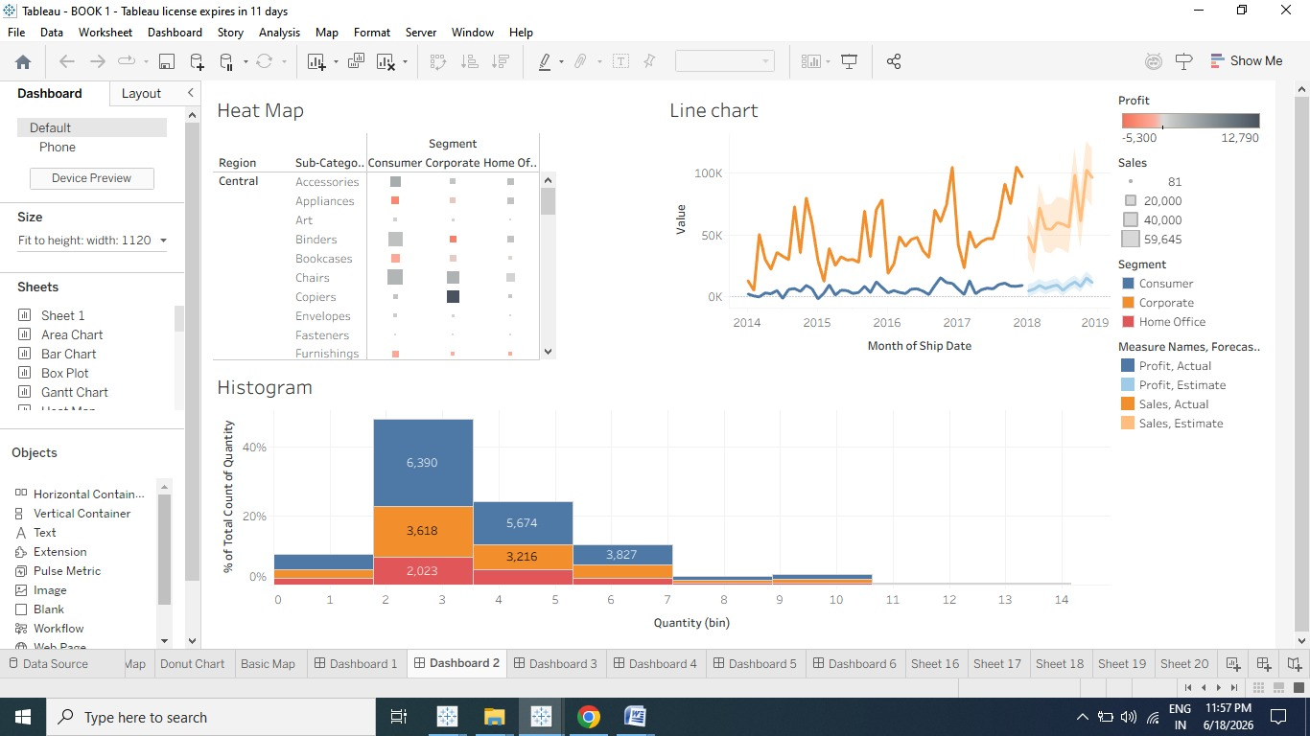

DASHBOARDS-3
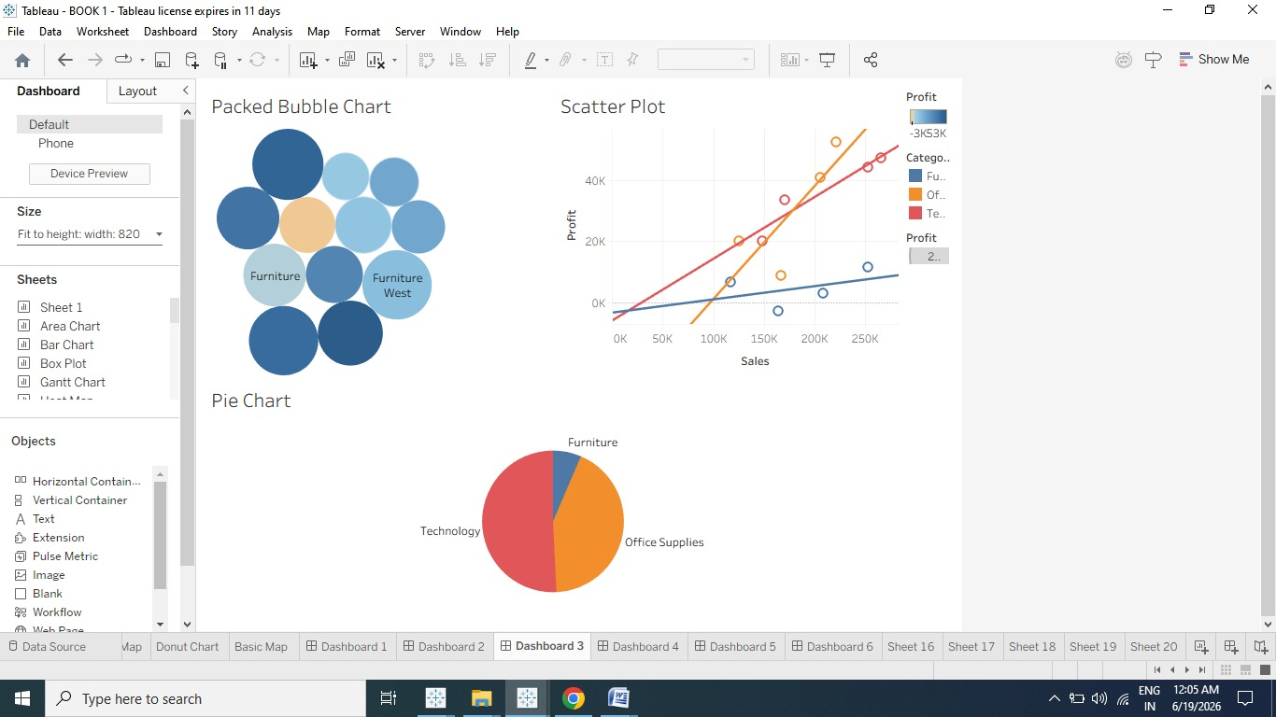
DASHBOARDS-4
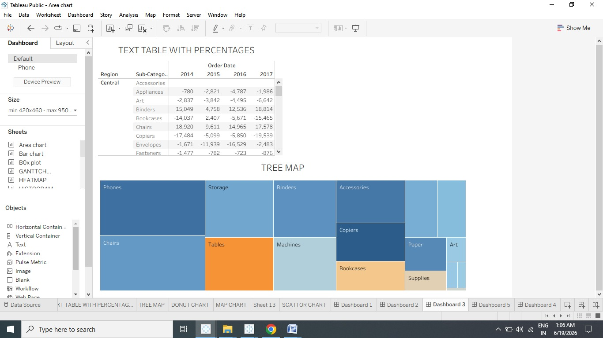

DASHBOARDS-5
